

**Keeping the Little Lights Shining**

**EasterSunday**

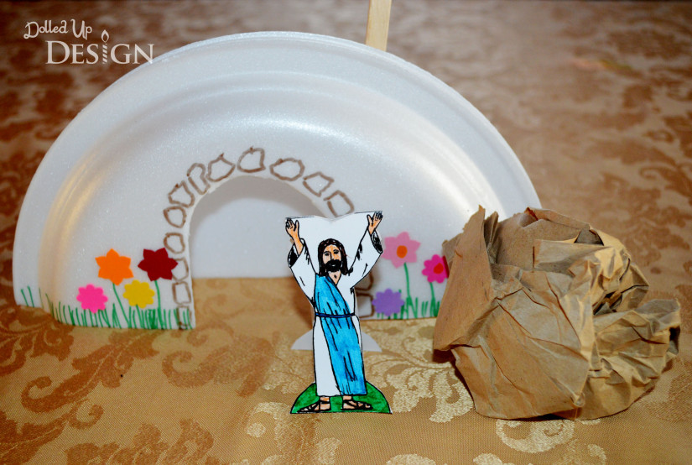



**Time to Reflect and Pray**

**You might like to take time each day as a family to share the things of the day that have made you happy, the things that you have enjoyed, those things which have made you anxious or worried, the things that have reassured you and made you feel safe, and all the things you are thankful for.**

**H**appy

**E**njoyed

**A**nxious

**R**eassured

**T**hankful

