**Keeping the Little Lights Shining**



**John 20:19-31**

**19**

It was the first day of the week. That evening Jesus’ followers were together. The doors were locked, because they were afraid of the Jews. Then Jesus came and stood among them. He said, “Peace be with you!” **20**After he said this, he showed them his hands and his side. His followers were very happy when they saw the Lord.

**21**Then Jesus said again, “Peace be with you! As the Father sent me, I now send you.”**22**After he said this, he breathed on them and said, “Receive the Holy Spirit. **23**If you forgive anyone his sins, they are forgiven. If you don’t forgive them, they are not forgiven.”

**24**Thomas (called Didymus) was not with the followers when Jesus came. Thomas was 1 of the 12. **25**The other followers told Thomas, “We saw the Lord.”

But Thomas said, “I will not believe it until I see the nail marks in his hands. And I will not believe until I put my finger where the nails were and put my hand into his side.”

**26**A week later the followers were in the house again. Thomas was with them. The doors were locked, but Jesus came in and stood among them. He said, “Peace be with you!”**27**Then he said to Thomas, “Put your finger here. Look at my hands. Put your hand here in my side. Stop doubting and believe.”

**28**Thomas said to him, “My Lord and my God!”

**29**Then Jesus told him, “You believe because you see me. Those who believe without seeing me will be truly happy.”

**30**Jesus did many other miracles before his followers that are not written in this book. **31**But these are written so that you can believe that Jesus is the Christ, the Son of God. Then, by believing, you can have life through his name.

<https://www.youtube.com/watch?v=GYmJSMe3AU8>



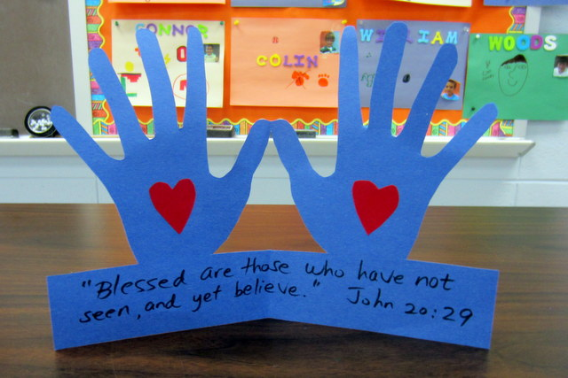

**Craft**

You might like to make a card like this one, and send it to someone you love to let them know that you are thinking of them.



**H**appy

**E**njoyed

**A**nxious

**R**eassured

**T**hankful

**Time to Reflect and Pray**

**You might like to take time each day as a family to share the things of the day that have made you happy, the things that you have enjoyed, those things which have made you anxious or worried, the things that have reassured you and made you feel safe, and all the things you are thankful for.**

**Let Us Pray**

This is a repeat-after-me prayer.

**Dear God,**

**Dear God,   
  
Thank you for the gift of Jesus.**

**Thank you for the gift of Jesus.**

**…who reminds and teaches us how...**

**…who reminds and teaches us how...**

**…to breathe in your Holy Spirit…**

**…to breathe in your Holy Spirit…**

**…that then replaces our worry and fear.**

**…that then replaces our worry and fear.**

**Thank you and Amen.**

**Thank you and Amen.**

**Help, Support and Prayer**

If there is anything we can do to help you and your family,

please don’t hesitate to be in contact.

Also you can follow us on: All Saints Church, Torre, Torquay.

*Fr. Peter March 01803 312754 p.j.march@hotmail.co.uk*