**Keeping the Little Lights Shining**



**Luke 24:13-35**

**19**

### 

**13**That same day two of Jesus’ followers were going to a town named Emmaus. It is about seven miles from Jerusalem. **14**They were talking about everything that had happened. **15**While they were discussing these things, Jesus himself came near and began walking with them. **16**(They were not allowed to recognize Jesus.) **17**Then he said, “What are these things you are talking about while you walk?”

The two followers stopped. Their faces were very sad. **18**The one named Cleopas answered, “You must be the only one in Jerusalem who does not know what just happened there.”

**19**Jesus said to them, “What are you talking about?”

The followers said, “It is about Jesus of Nazareth. He was a prophet from God to all the people. He said and did many powerful things. **20**Our leaders and the leading priests gave him up to be judged and killed. They nailed him to a cross. **21**But we were hoping that he would free the Jews. It is now the third day since this happened. **22**And today some women among us told us some amazing things. Early this morning they went to the tomb, **23**but they did not find his body there. They came and told us that they had seen a vision of angels. The angels said that Jesus was alive! **24**So some of our group went to the tomb, too. They found it just as the women said, but they did not see Jesus.”

**25**Then Jesus said to them, “You are foolish and slow to realize what is true. You should believe everything the prophets said. **26**They said that the Christ must suffer these things before he enters his glory.” **27**Then Jesus began to explain everything that had been written about himself in the Scriptures. He started with Moses, and then he talked about what all the prophets had said about him.

**28**They came near the town of Emmaus, and Jesus acted as if he did not plan to stop there. **29**But they begged him, “Stay with us. It is late; it is almost night.” So he went in to stay with them.

**30**Jesus sat down with them and took some bread. He gave thanks for the food and divided it. Then he gave it to them. **31**And then, they were allowed to recognize Jesus. But when they saw who he was, he disappeared. **32**They said to each other, “When Jesus talked to us on the road, it felt like a fire burning in us. It was exciting when he explained the true meaning of the Scriptures.”

**33**So the two followers got up at once and went back to Jerusalem. There they found the 11 apostles and others gathered. **34**They were saying, “The Lord really has risen from death! He showed himself to Simon.”

**35**Then the two followers told what had happened on the road. They talked about how they recognized Jesus when he divided the bread.



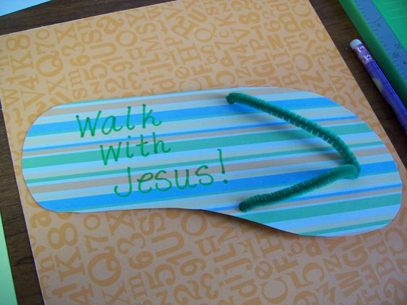

**Craft**

Make and decorate sandals like these to remember that Jesus walks with us wherever we go.





**Let Us Pray…**

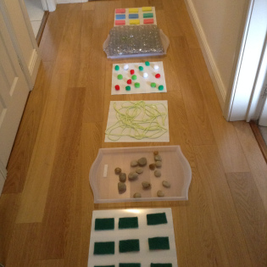

Jesus and the two disciples walk together. Have a go at making your own prayer walk, like the one in the picture. You can use whatever you have at home. Then follow the prayer walk, pausing at each step to speak to God. Take off your shoes for the full effect!

**H**appy

**E**njoyed

**A**nxious

**R**eassured

**T**hankful



**Time to Reflect and Pray**

**You might like to take time each day as a family to share the things of the day that have made you happy, the things that you have enjoyed, those things which have made you anxious or worried, the things that have reassured you and made you feel safe, and all the things you are thankful for.**

**Help, Support and Prayer**

If there is anything we can do to help you and your family,

please don’t hesitate to be in contact.

Also you can follow us on: All Saints Church, Torre, Torquay.

*Fr. Peter March 01803 312754 p.j.march@hotmail.co.uk*